Bracket Design :

Material : Mild steel

Yield strength = 250 Mpa

Ultimate tensile strength = 550 Mpa

Stress = 0.5 (ultimate tensile strength)

= 0.5 x (550) = 275 Mpa

Stress = Net force acting on the bracket / (cross sectional area)

Net force acting = sqrt(x component force^2 + y component force^2)

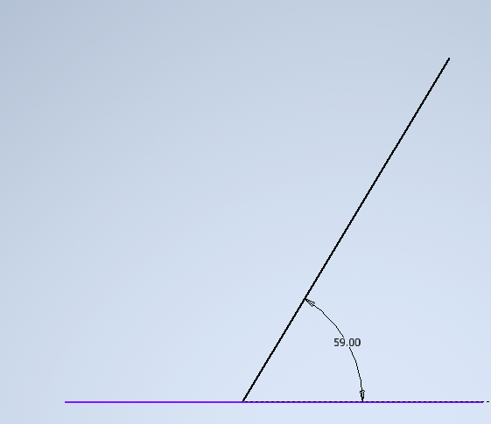

Cross section of the bracket where force is experienced :

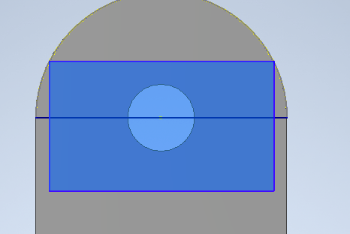

Length of the cross section :



thickness of the bracket:

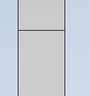

X axis net force = 4452.538 N + 6653.739 \* cos(59) (from wishbone calculation)

= 7879.466 N

Yaxis net force = 6653.739 \* sin(59)

= 5703.367 N

Total force = sqrt (x axis net force ^2 + y axis net force ^2 )

= 9727.149 N

Stress = force / area where , area = length x thickness

275 =9727.149/2\*(area)

Area = 22.57 mm^2

From which we get ,

For thickness = 2mm

We get ,

Length of the bracket cross section = 11.285 mm

In order to obtain a safer and efficient design ,

We assign thickness = 4 mm

Therefore,

Length of the bracket cross section = 5.642 mm